Lab # 6 — Assessment Worksheet

**Course Name and Number: FRS301**

**Student Name: Tran Thanh Tuan**

**Student Id: SE161095**

**Instructor Name: Nguyen Van Vinh**

**Viewing Forensically Important Registry Keys with Regedit**

***Creating a Restore Point on the Windows 7 Machine***

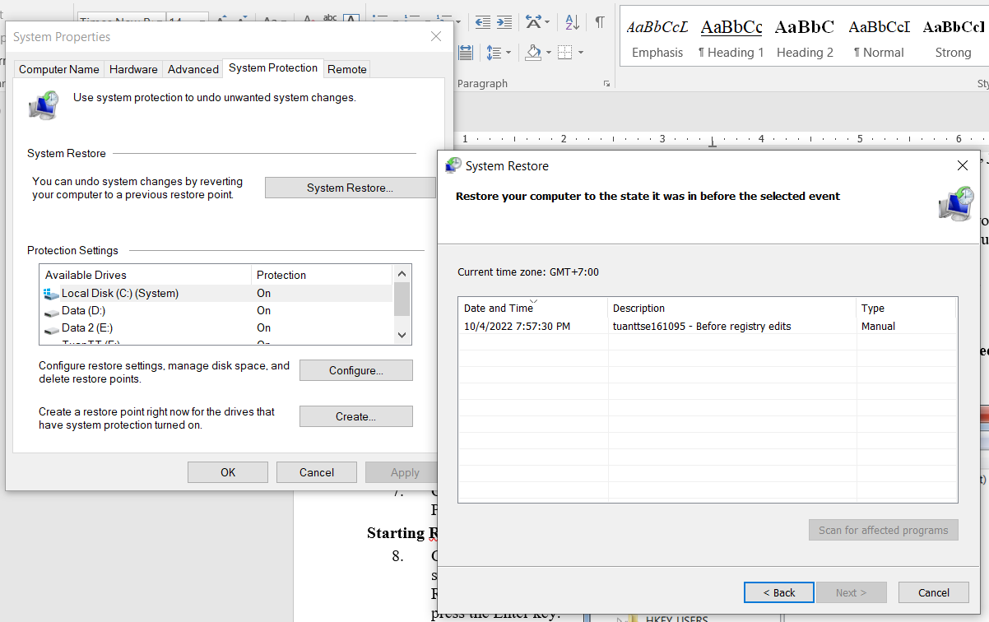

***Starting Regedit***

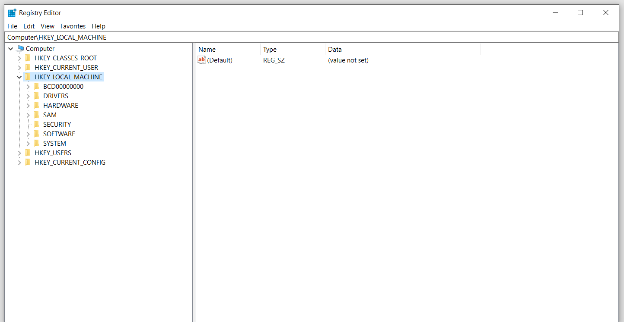

***USB Devices***

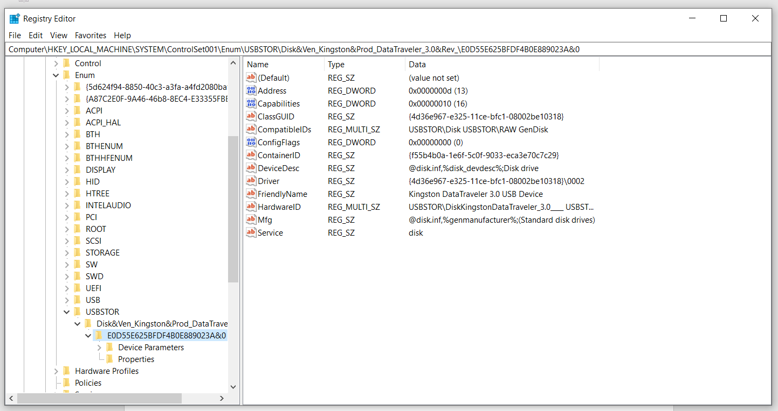

***Understanding Control Sets***

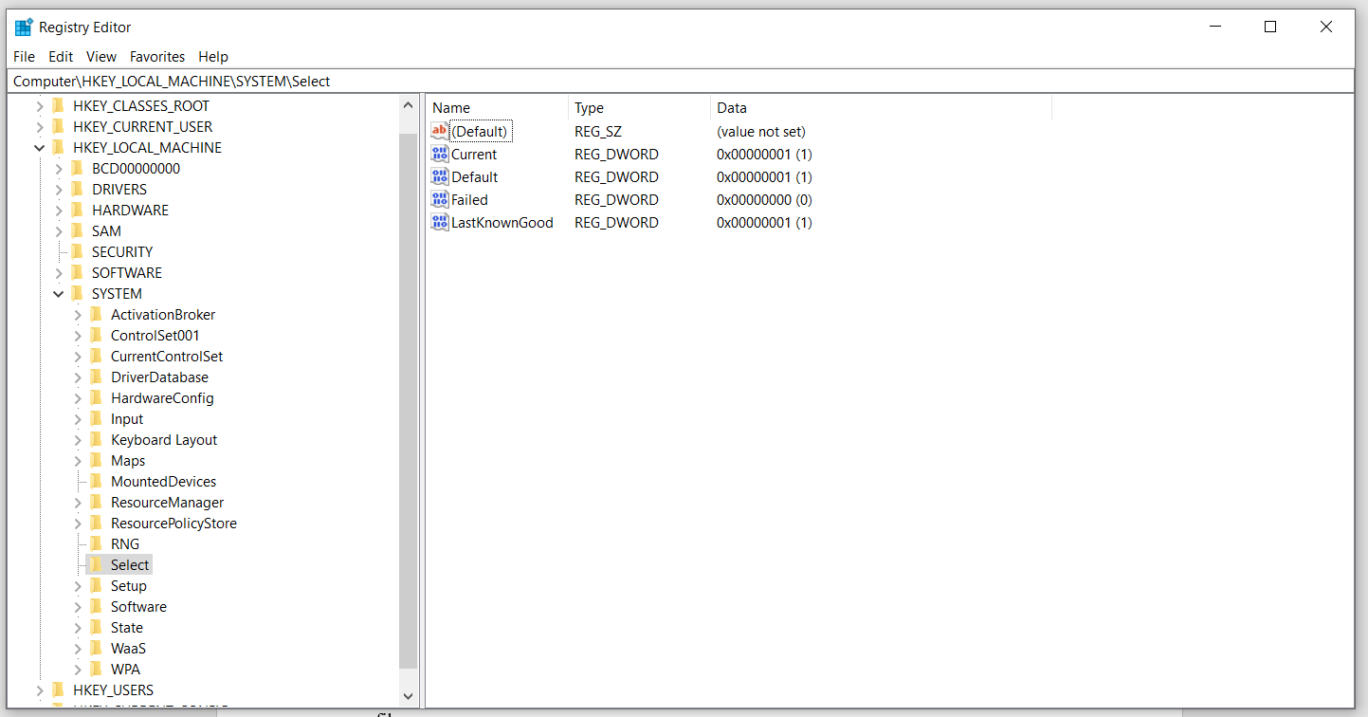

***UserAssist***

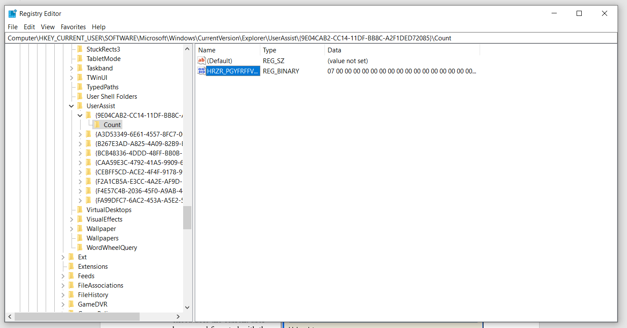

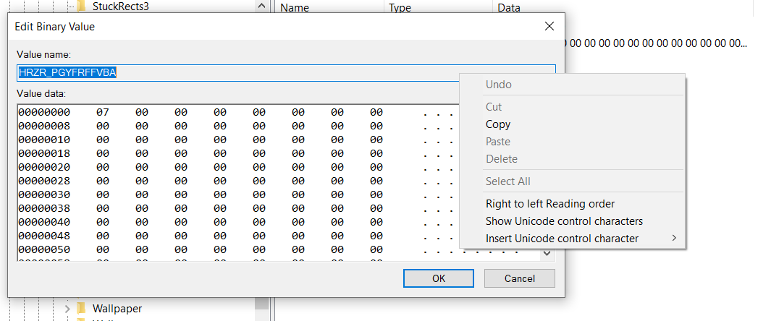

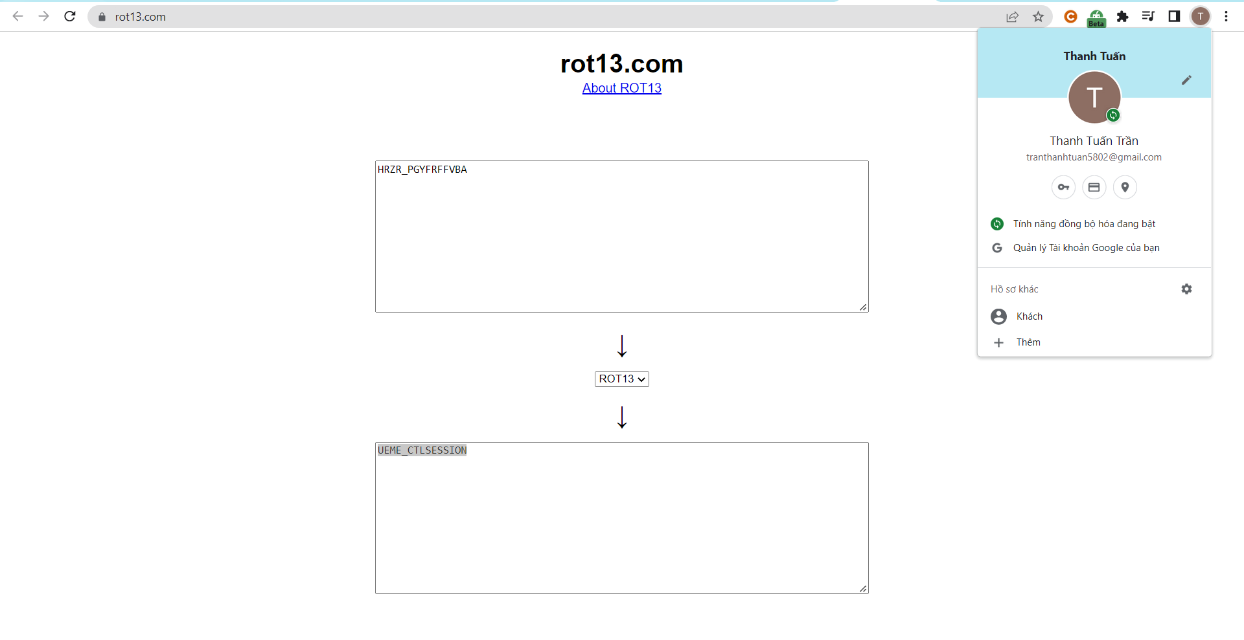

***Internet Explorer TypedURLs***

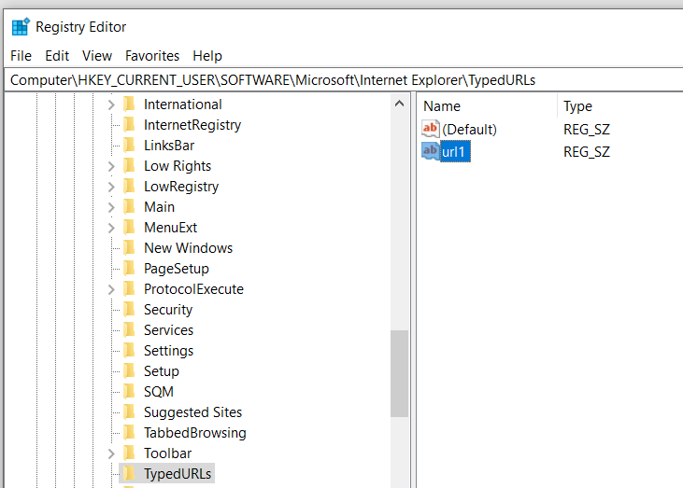

***Saving a Screen Image***

